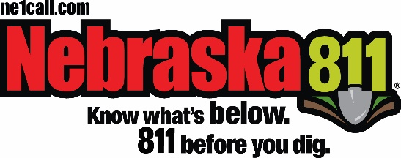
FOR IMMEDIATE RELEASE

Media Contact:
Jill Geyer
402-676-1989
jillgeyer@occinc.com

The COVID-19 pandemic coincides with spring digging projects making utility locate requests more important than ever.

Nebraska (April 14, 2020) -- Amid the COVID-19 pandemic, it’s more important than ever for communities to remain safe and connected to critical utility services, including internet and other communications lines. For anyone planning projects that require digging this spring in Nebraska -- including homeowners and contractors – Nebraska811 reminds them to utilize the free service. Excavators may access 811 online or by phone to enter requests and notify the affected utility companies so that important underground lines are marked prior to breaking ground.

Anyone who plans to dig should go to their state 811 center’s website or call 811 before digging to request that the approximate location of buried utilities be marked. The state 811 center will take the online user or caller’s information and communicate it to local utility companies. Professional locators will then either indicate that the excavator is clear to dig or visit the dig site to mark the approximate location of underground utility lines with spray paint, flags or both. Once a site has been accurately marked or the utility company has communicated to the excavator that they are clear, it is safe to begin digging. Excavators should confirm that all utilities listed on their locate request have responded before beginning excavation. For private utility lines, it is the owner’s responsibility to determine their location. Utilities will not locate and mark privately owned lines.

Nebraska811 encourages homeowners to take the following steps when planning a digging project this spring:
- Always call 811 before digging, regardless of the depth or familiarity with the property.
- Plan ahead. Call ahead of time if work is planned for an upcoming weekend, providing ample time for the approximate location of lines to be marked.
- Confirm that all lines have been marked and all utilities have responded.
- Consider moving the location of your project if it is near utility line markings.
- If a contractor has been hired, confirm that a call to 811 has been made. Don’t allow work to begin if the lines aren’t marked.
- Visit www.ne1call.com for complete information.

Digging without knowing the approximate location of underground utilities can result in serious injuries, service disruptions and costly repairs when gas, electric, communications, water and sewer lines are damaged. Cooperation to help ensure continued public safety and sustainable utility service during these difficult times is vital. With so much at stake for public health and safety right now, the millions of Americans who plan to do digging projects this year without taking the important step of calling 811 beforehand are taking an unnecessary risk—and one that could impact an entire community.

About Nebraska811
Nebraska811 is a FREE service for anyone who is planning a digging project, including homeowners and professional excavators. Nebraska State law requires anyone who digs to place a locate request at least before digging. Once your request is submitted, utilities will respond by clearing or locating and marking their lines.

By placing a call or an online request with Nebraska811, damage to underground utility lines can be prevented as well as costs for repairs, loss of use and injury. It’s FREE. It’s EASY. It’s the LAW.

Locate requests are placed by calling 811 or 800-331-5666, or online at www.ne1call.com
# # #

