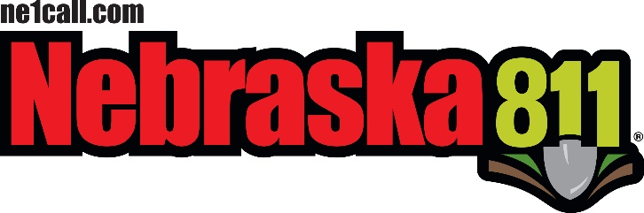
STATEWIDE ONE-CALL NOTIFICATION CENTER
BOARD OF DIRECTORS BOARD MEETING AGENDA

December 5th, 2019
Location:
Country Inn and Suites
5353 N 27th Street
Lincoln, Ne. 68521
Committee Meetings: 9:00 am Board meeting: 10:00 am

- Call Meeting to Order
  - Housekeeping -
  - Meeting Notice posted –
  - On the Web –
  - Announcements -

- Roll Call

- Introductions
  - Guest’s introductions

- Approval of Meeting Agenda

- Approval of Minutes of the previous Meeting
  - August 21, 2019 board meeting

- Public Comment – (15 minutes -Questions or concerns for the board)

- Committee Reports
  - Policy Committee
    - Dave S.
    - ACTION ITEMS:
    - Letter to Private Locator / Locating training
    - Damage / Incorrect Locate
    - Legislature Committee – Andy

    - ACTION ITEMS:

  - Advertising Committee
  - Jerry Augustine
    - ACTION ITEMS:
      - 2020 Budget number for Advertisement / Education

  - Bylaws Committee – Stan Waterman /

    - ACTION ITEMS:
      - Updating after Rule and Reg Chapter 1 & 2 are in effect.

  - Best Practices committee - Dan M. /

    - ACTION ITEMS:
    - Dan is excused from meeting / No updates

New Technology committee – Lance / Val
    - ACTION ITEMS:

- DPRC Center Report
  - DPRC Status Report – Tyler
  - Outreach Report – Jill
  - Questions for Jill or Tyler

    - ACTION ITEMS:
    - TBD

- Treasurer’s Report
  - John’s Report
  - Approval of the Treasurer’s Report
  - Questions / Concerns

  - ACTION ITEMS:
    - TBD

- State Fire Marshal’s Report
  - David’s Report & Updates –
  - Kevin’s Report and Meeting updates for 2019
  - Regina’s Updates –

Updated Manuel for Board Members and new Members
  - Questions / Concerns for David, Kevin or Regina

  - ACTION ITEMS:

- Non-Compliance Report – Ne. AG’s Office
  - Report from NE. State Fire Marshal’s Office

  - ACTION ITEMS:
    - TBD

- Old Business

Explanation of the boards Insurance policy /
- Action / Follow up Items
- • Second round of rule/reg changes - Dave
• Manual changes – committee to draft - Jill, Dave, SFM reps, John, Dan,

Tyler
• Tutorial videos for Next Gen/ InSite /LTM - Tyler
• Meeting with AG to determine alternatives to dispute resolution board –

Regina, John, Dave, BJ, other board members
• Status of By Laws - Stan
- Manuel Update – Jill
- Meeting Restriction – Tyler

• Map data – Regina

- New Business

- Status Codes on Positive Response
  - We need to revisit these again as a board

New Committee Lists – Val

- Meeting Change for March

- ACTION ITEMS:

- Common Ground of Nebraska Report
- CGN Updates –
  - Abandoned UG Facilities
- 2020 Underground Safety Summit -
- Next CGN Meeting –

- Closing Comments from the Board Chair

One message / the same message

  - Next meeting date and site – January 23rd in Lincoln (Country Inn and suites )

- Adjournment

The public may request that items be added to the Agenda if such requests are received 24 Hours prior to any scheduled meeting. Requests must be in writing and directed to:

Val Snyder, NE811 Board Chairperson; 3808 28th Ave. Suite B. Kearney, Nebraska 68845
Or

E Mail to – val.snyder@tallgrassenergylp.com

